Q1. WAQ to display the details of all countries.

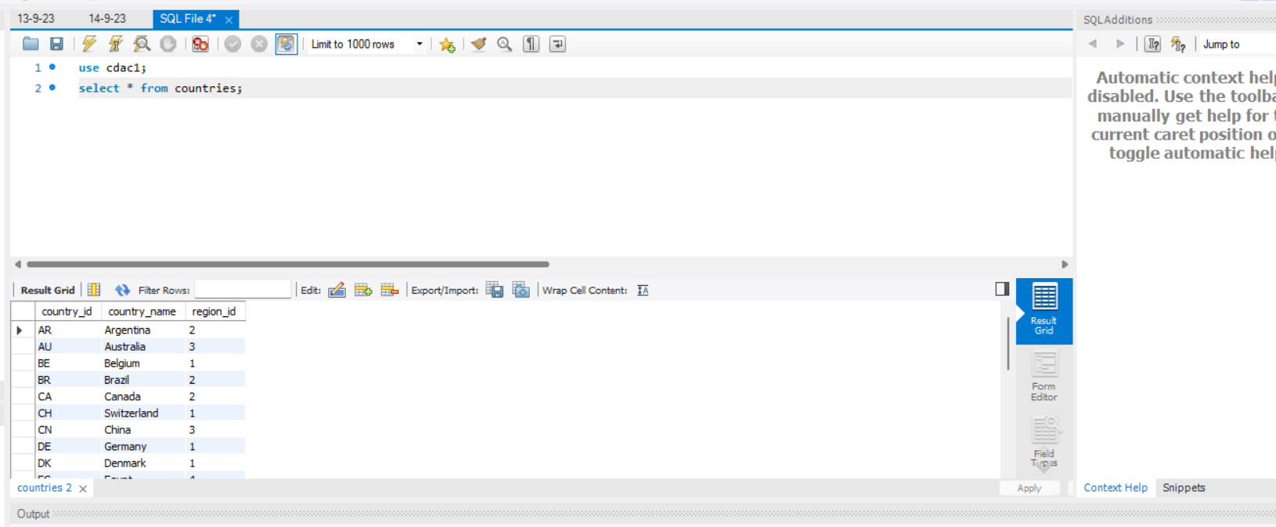

Q2. WAQ to display the employee number,name,phonenumber of those employees who are in department 8.

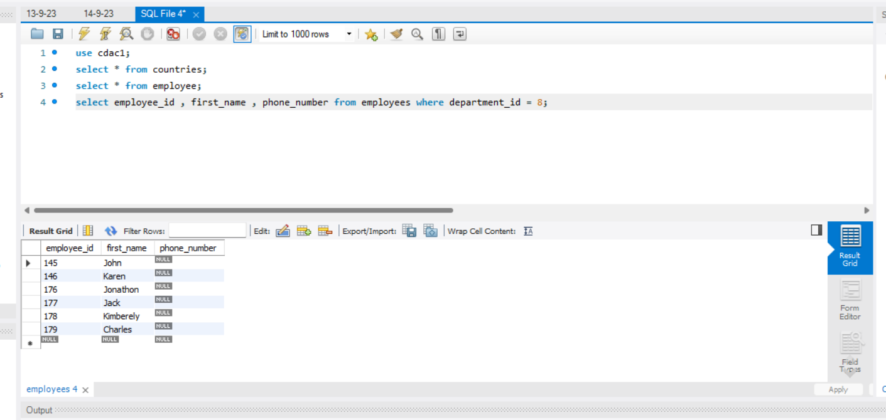

Q3. WAQ to display details of those employees who were hired in the year 4th Jan 2000.

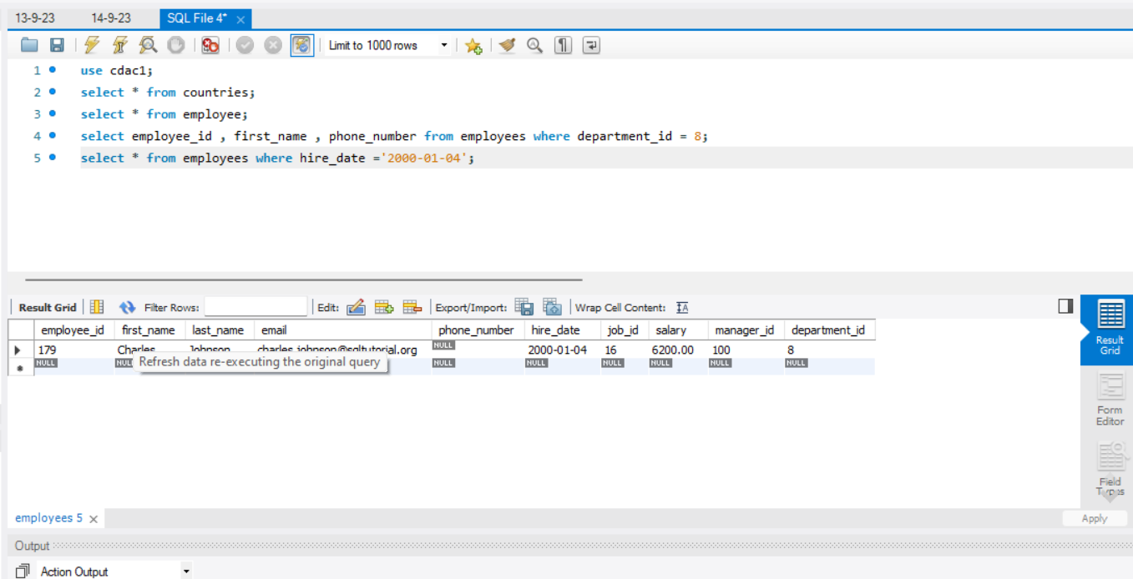

Q4. WAQ to display details of those employees who jobid is 10 and salaries are less than 10000.

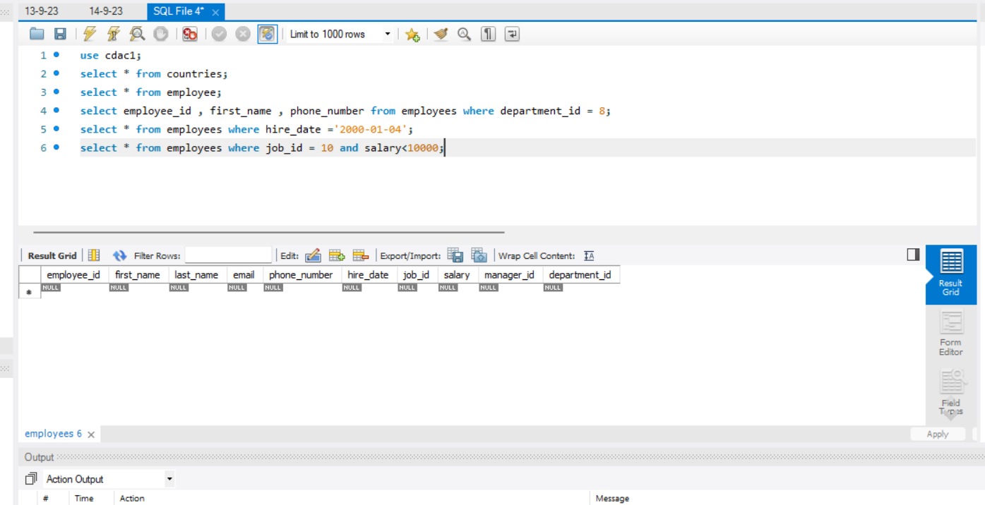

Q5. WAQ to display the details of those employees either department is 6 or the hiredate is in year 31st Dec 1999.

